# CHAPTER9 AROMATIC HYDROCARBONS

|  |
| --- |
| **In This Chapter You Will Learn** |
|  |
| 1. To name simple aromatic hydrocarbons, and their derivatives. 2. The Kekule and resonance approaches to explain the structure and stability of benzene. 3. About the preparation of benzene. 4. About the electrophilic substitution, oxidation and addition reactions of benzene. 5. About the isomerism which arises when a second substituent enters the ring. 6. How does the presence of a group alters the reactivity of benzene ring towards electrophilic substitution reactions. 7. The comparison of reactivities of alkanes, alkenes and benzene. |

## **9.1 INTRODUCTION**

The term aromatic was derived from the Greek word ‘aroma’ meaning “fragrant” and was used in Organic Chemistry for a special class of compounds. These compounds have a low hydrogen to carbon ratio in their molecular formula and have a characteristic odour. However, it was soon realized that many aromatic compounds are odourless whereas many others are fragrant though they are not aromatic.

Further, when aromatic compounds of higher molecular mass were subjected to various methods of degradation, they often produced benzene or derivatives of benzene. It was observed that almost all the aromatic compounds have a six carbon unit in their molecules like benzene. Hence, benzene was recognized as the simplest and the parent member of this class of compounds.

So aromatic hydrocarbons include benzene and all those compounds that are structurally related to benzene.

*Animation 9.1 :* [*Polycyclic aromatic hydrocarbn*](http://qchitool-pah-dev.oa-cagliari.inaf.it/)

*Source & Credit :* [*Qchitool*](http://qchitool-pah-dev.oa-cagliari.inaf.it/)

It appears from the definition of aromatic hydrocarbons that any study of this class of compounds must begin with the study of benzene. Benzene has characteristic structural features. It has a regular planar hexagonal structure. On the basis of the number of benzene rings aromatic hydrocarbons can be categorized into following classes.

1. Monocyclic Aromatic Hydrocarbons and their derivatives
2. Polycyclic Aromatic Hydrocarbons
3. Monocyclic Aromatic Hydrocarbons and their Derivatives

|  |
| --- |
| 2 3 |

Aromatic hydrocarbons containing one benzene ring in their molecules are called Monocyclic Aromatic Hydrocarbons, e.g. benzene and its derivatives.

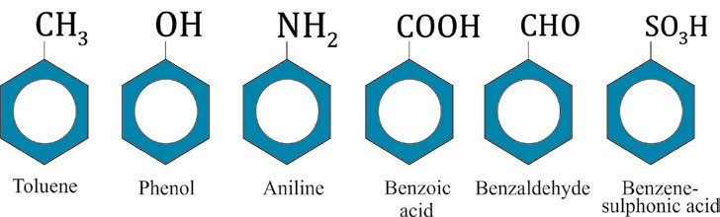

1. Polycyclic Aromatic Hydrocarbons

Aromatic hydrocarbons containing two or more benzene rings in their molecules are called Polycyclic Aromatic Hydrocarbons. They may be divided into two main classes.

1. Those in which benzene rings are isolated, e.g. bi phenyl,diphenylmethane, etc.

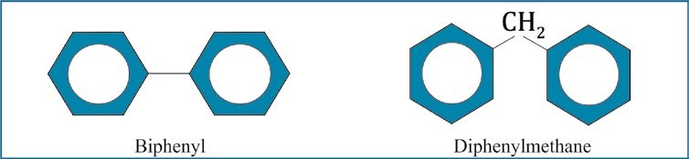

1. Those in which the benzene rings are fused together at ortho positions so that the adjacent rings have a common carbon to carbon bonds, e.g. naphthalene, phenanthrene and anthracene

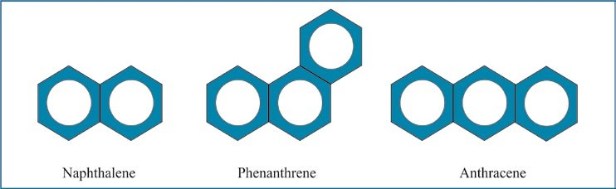

*Animation 9.2 :* [*Larger cyclic aromatic hydrocarbons*](http://www.sandia.gov/~ajasper/pub/)

*Source & Credit :* [*sandia*](http://www.sandia.gov/)

## **9.2 NOMENCLATURE**

### (Monocyclic Aromatic Hydrocarbons and their Derivatives)

The nomenclature of the aromatic hydrocarbons is much more complex than that of aliphatic hydrocarbons. The system used for naming benzene and its derivatives generally depends on the number of substituents on the benzene ring.

Some important rules of naming are given below.

1. Mono-substituted benzene derivatives are named by prefixing benzene with the name of the substituent. The whole name is written as one word, e.g.

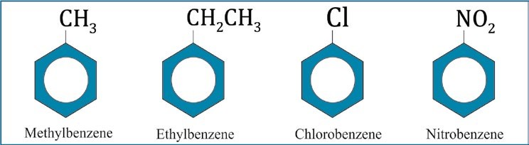

|  |
| --- |
| 4 5 |

1. There are certain monosubstituted benzene derivatives which are given the special names, like methylbenzene as toluene, hydroxybenzene as phenol etc.

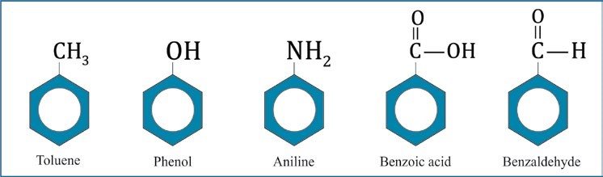

All the six positions in benzene are exactly equivalent so there is only one monosubsituted benzene.

When a hydrogen atom is removed from benzene, we get a phenyl group symbolized by C6H5- or Ph-. Substituted phenyl groups are called aryl groups.

1. The second substituent in benzene would give rise to three isomeric products designated as ortho (1,2), meta(1,3) and para(1,4),e.g.

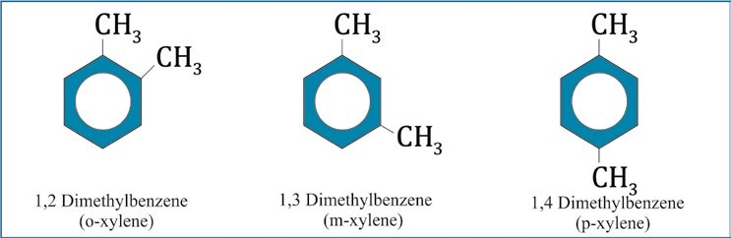

1. If two or more substituents are different, then the substituent that is treated as a high priority group, is given the number 1 position in the benzene ring. Other groups are numbered by counting from position 1 in the manner which gives them the lowest number.

*Animation 9.3 :* [*Monocyclic ring breathing mode in Toluene*](http://www.kemi.dtu.dk/english/Research/PhysicalChemistry/Raman_Spektroskopi/UV_Raman_Spectroscopy)

*Source & Credit :* [*Kemi*](http://www.kemi.dtu.dk/)

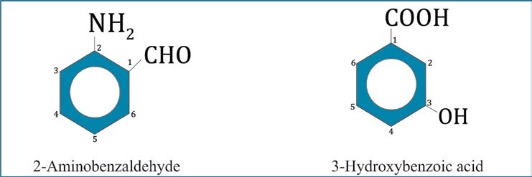

The order of priority of the groups (left to right):

— COOH, — CN, — CHO, — COCH3, — OH, — NH, — OR, — R.

1. If the two substituents are different and they are not present in priority order list, they are named in alphabetical order. The last named substituent will be at position 1, e.g.,

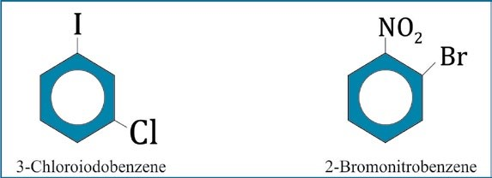

|  |
| --- |
| 6 7 |

1. If there is a substituent on the ring which gives a special name to the molecule, then special name is used as parent name to the molecule, e.g.

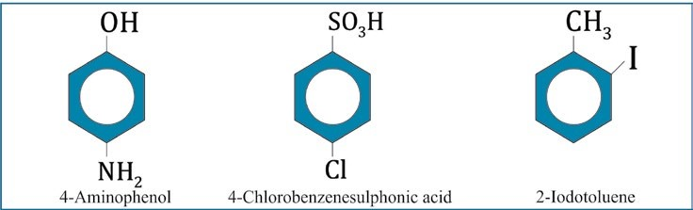

## **9.3 BENZENE**

Benzene was discovered by Michael Faraday in 1825 in the gas produced by the destructive distillation of vegetable oil and twenty years later it was also found in coal-tar by Hoffmann.

### 9.3.1 Structure of Benzene

**Molecular Formula**

1. The empirical formula of benzene is determined by the elemental analysis.
2. Its molecular mass determined by the vapour density method is 78.108. This is six times the empirical formula mass (CH = 12 + 1 = 13). Therefore, the molecular formula of benzene is C6H6.
3. The molecular formula of benzene indicates that it is highly unsaturated compound.

**9.3.2 Straight Chain Structures Ruled Out:**

i) Two of the possible straight chain formulas suggested for benzene are :

HC C≡ CH2 CH2 C CH≡ (1,5-Hexadiyne).

HC=CH2 C C≡ CH=CH2  (l,5-Hexadiene-3-yne).

A compound having a structure as above should behave like an alkene or alkyne, both are oxidized by alkaline KMnO4 solution. On the contrary, benzene is stable to KMnO4 solution i.e. it does not decolorize KMnO4 solution. Benzene gives addition reactions with hydrogen and halogens, which indicate the presence of three double bonds.

But benzene also gives substitution reactions with conc. HNO3 and conc. H2SO4 which indicate that benzene has a saturated structure.

ii) Considering a straight chain structure for benzene and further assuming that each carbon carries one H-atom, it should be capable of forming three monosubstitution products.

X X X

| | |

C.C.C.C.C.C C.C.C.C.C.C C.C.C.C.C.C

But benzene yields only one monosubstituent product.

iii) The molecular formula of benzene C6H6 does not correspond to any of the open chain hydrocarbons, such as alkane CnH2n+2(C6H14), alkene CnH2n(C6H12) or alkyne CnH2n-2 (C6H10).

It means benzene does not belong to open chain hydrocarbon and therefore possibility of a straight chain structure is ruled out.

### 9.3.3 Kekule’s Structure

The structure of benzene continued to be a serious problem for chemists for about 40 years. A German chemist, Kekule at last solved the problem in 1865. Kekule proposed a cyclic regular hexagonal structure for benzene, which contains three double bonds alternating with three single bonds.

He supported his theory by the following arguments.

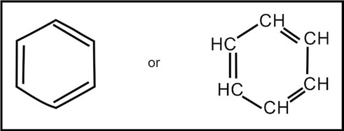

(i) Benzene gives only one monosubstituted product.

8 9

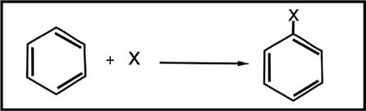

1. Benzene gives only three disubstituted products.

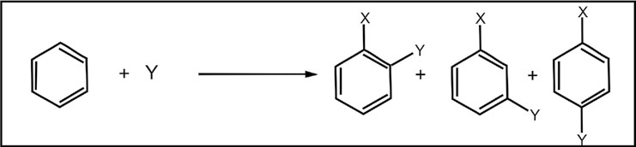

These points confirm the regular hexagonal structure for benzene in which all the carbon atoms are occupying identical positions in the molecule. Therefore, benzene forms only one toluene, one phenol and one nitro benzene.

1. Benzene adds three hydrogen molecules in the presence of a catalyst.

*Animation 9.4 :* [*Phenol and Alcohol*](http://www.footdoc.ca/www.FootDoc.ca/Website%20Ingrown%20Nail%20Procedures.htm)

*Source & Credit :* [*footdoc*](http://www.footdoc.ca/)

10

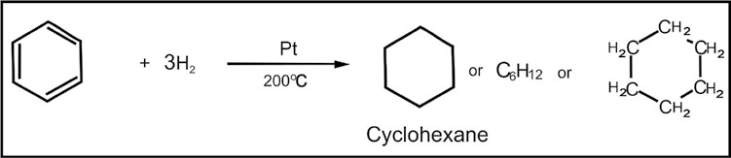

iv) Benzene adds three molecules of chlorine in the presence of sunlight.

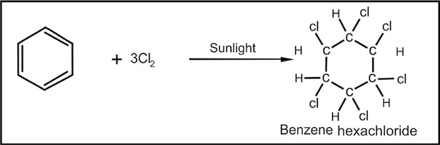

These two reactions confirm the presence of three double bonds alternating with three single bonds.

#### 9.3.4 X-Ray Studies of Benzene Structure

The X-ray studies of benzene have confirmed the hexagonal structure for it. These studies have also revealed that all the carbon and hydrogen atoms are in the same plane. All the angles are of 120°. All C - C and C -H **o o** bond lengths are 1.397A and 1.09 A, respectively.

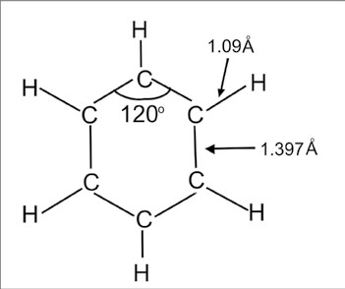

#### Objections to Kekule’s Formula

Kekule’s formula with three double bonds demands a high degree of unsaturation from benzene while usually it exhibits a saturated character. Thus benzene yields substitution products readily and forms addition products reluctantly. Benzene is also a very stable compound. All these properties of benzene can be easily explained using the modem theories about its structure.

11

**9.3.5 Modern Concepts About the Structure of Benzene Atomic Orbital**

##### Treatment of Benzene

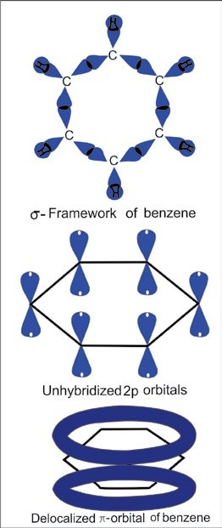The hexagonal frame-work of benzene can be conveniently explained using hybridization approach. According to this, each carbon in benzene is sp2 hybridized. The three sp2 hybrid orbitals on each carbon are utilized to form three s-bonds, two. with adjacent carbon atoms and one with hydrogen.

The unhybridized 2pz orbitals remain at right angle to these sp2 orbitals. Since all the sp2 orbitals are in the same plane therefore all the carbon and hydrogen atoms are coplanar.

All the angles are of 120° which confirms the regular hexagonal structure of benzene. The unhybridized 2pz orbitals partially overlap to form a continuous sheath of electron cloud, enveloping, above and below, the six carboncarbon sigma bonds of the ring. Since each 2pz orbital is overlapped by the 2pz orbitals of adjacent carbon atoms, therefore, this overlapping gives, 'diffused' or 'delocalized' electron cloud.

### 9.3.6 The Stability of Benzene

As mentioned earlier benzene is an extraordinary stable molecule. This stability is due to the extensive delocalization of electron cloud. The extent of stability of benzene can be measured by comparing it with hypothetical compound, 1,3,5- cyclohexatriene. This can be done by estimating their heats of hydrogenation.

12

Cyclohexene, a six membered ring containing one double bond, can be easily hydrogenated to give cyclohexane. When the  H for this reaction is measured it is found to be -119.5 kJ/mole, very much like that of any similarly substituted alkene.

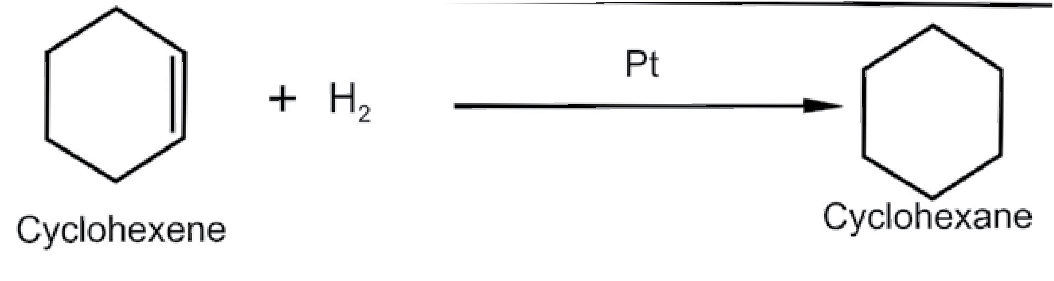

|  |
| --- |
| *Animation 9.5 :* [*Kekulé benzene*](http://www.ch.imperial.ac.uk/rzepa/blog/?p=12560) *Source & Credit :* [*Ch.imperial*](http://www.ch.imperial.ac.uk/) |

We would expect that hydrogenation of 1,3-cyclohexadiene would liberate roughly twice as much heat and thus have  H equal to about -239 kJ/mole. When this experiment is done, the result is  H = -231.5 kJ/mole. This result is quite close to what we calculated, and the difference can be explained by taking into account the fact that compounds containing conjugated double bonds are usually somewhat more stable than those containing isolated double bonds.

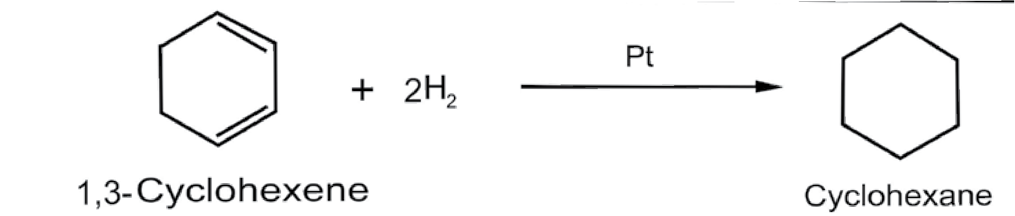

**1**

**,3-Cyclohexadiene**

Calculated  H = 2(-119.5) = -239 kJ/mole

Observed  H = -231.5 kJ/mole

If we extend this kind of thinking, and if benzene is simply

1,3,5-cyclohexatriene, we

13

would predict that benzene would liberate approximately -358.5 kJ/mole (3 x -119.5) when it is hydrogenated. When the experiment is actually done the result is surprisingly different. The reaction is exothermic but only by -208 kJ/mole.

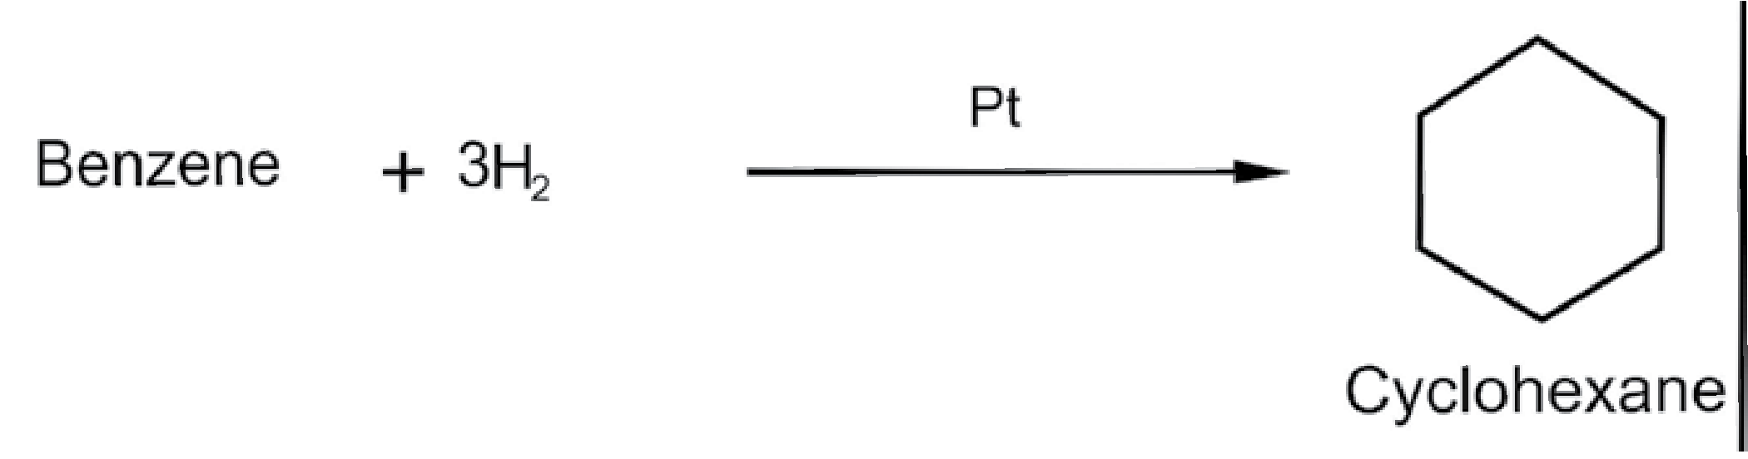

Calculated  H = (3 x -119.5) =-358.5 kJ/mole

Observed  H = -208 kJ/mole

Difference = 150.5 kJ/mole

When the results are represented by the following figure, it becomes clear that benzene is much more stable than we calculated it to be.

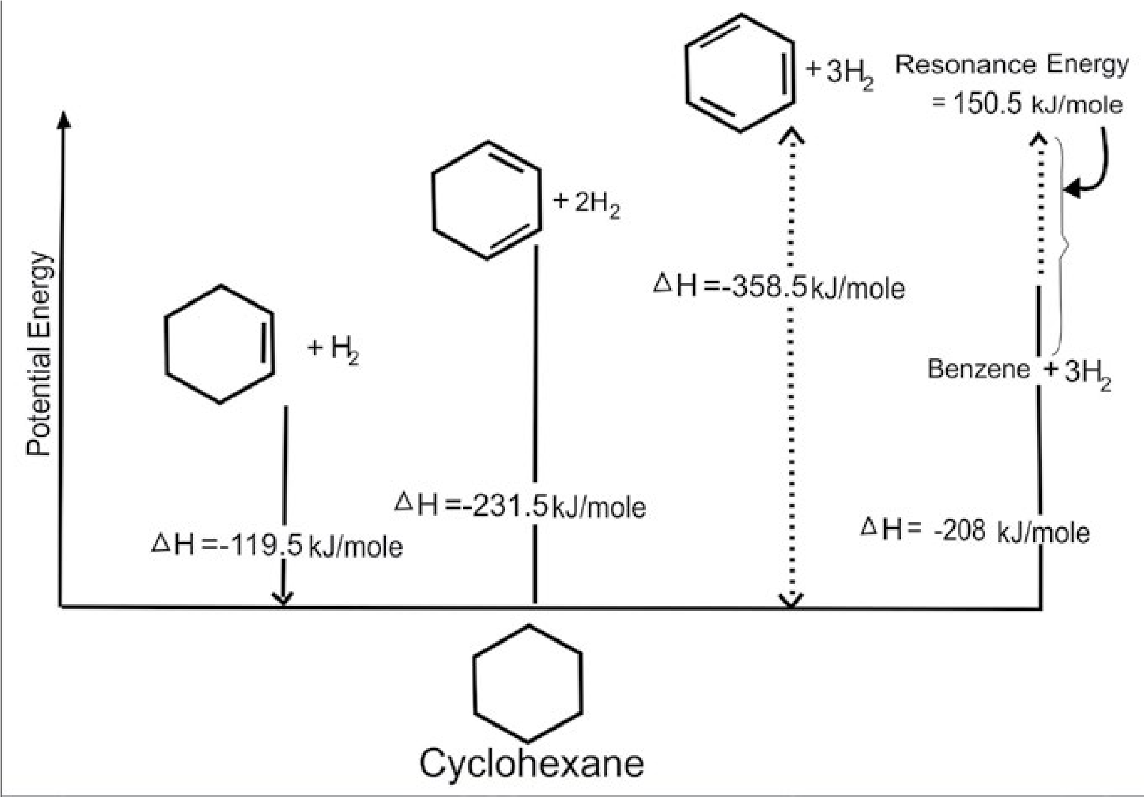

*Fig.9.1 Relative stabilities of Cyclohexene,1,3- Cyclohexadiene, 1,3,5-Cyclohexatriene (hypothetical) and benzene.*

14

|  |  |  |  |
| --- | --- | --- | --- |
| |  | | --- | | *Animation 9.6 :* [*Benzene derivative*](http://www.cod.edu/people/faculty/jarman/richenda/1551_materials/HTML/SkelatalBenzene.html) *Source & Credit :* [*Cod.edu*](http://www.cod.edu/) | | |  | | --- | | *Animation 9.7 :* [*Bonding in a molecule of benzene from a molecular orbital point*](https://s10.lite.msu.edu/res/msu/botonl/b_online/library/newton/Chy251_253/Lectures/Aromaticity/AromaticityFS.html)  *Source & Credit :* [*lite.msu.edu*](https://s10.lite.msu.edu/adm/roles) | |

Indeed, benzene is more stable than the hypothetical 1,3,5-cyclohexatriene by 150.5 kJ/mole. This difference between amount of heat actually released and that calculated on the basis of the Kekule’s structure is now called the ‘Resonance energy’ of the compound. It means benzene shows the phenomenon of resonance which makes it more stable than others. In benzene electrons are delocalized making it a very stable molecule.

**9.3.7 The Resonance Method**

### Resonance

|  |  |
| --- | --- |
| “The possibility of different | pairing schemes of valence |
| electrons of atoms is called | resonance” and the different |
| structures thus arranged are | called “Resonance structures”. |
| The resonance is represented | by a double headed arrow |

(↔ ) e.g. the following different pairing schemes of the fourth valence (the p-electrons) of carbon atoms are possible in benzene.

15

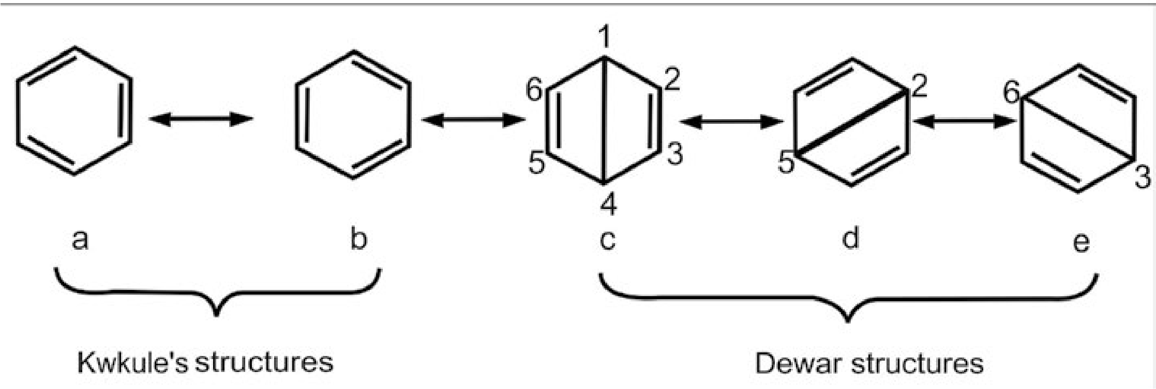

**e**

(a), (b) were proposed by Kekule and c, d, e, were proposed by Dewar. The stability of a molecule increases with increase in the number of its resonance structures. Thus molecule of benzene is chemically quite stable.

In Dewar structure the carbon atoms at opposite positions 1-4, 2-5 and 3-6 are at larger distances than those in the adjacent positions 1-2,2-3,3-4,4-5,5-6 and 6 -1. Therefore the bondings between C1-C4, C2-C5 and C3-C6 are not favourable energetically.

Hence the Dewar structures for benzene have minor contribution towards the actual structure of benzene.

Infact, the structure of benzene is a resonance hybrid of all the five structures (a), (b), (c), (d) and (e) in which the Kekule’s structure (a) and (b) have the larger contribution. Therefore, benzene molecule can be represented by either of the two Kekule’s structure.

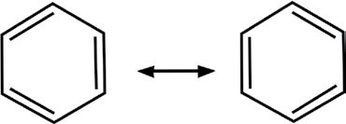The three alternate single and double bonds in the Kekule’s structures are called conjugate bonds or resonating bonds.

Since the structure of benzene is a resonance hybrid, therefore all the C-C bond lengths are equal but different from those in alkanes, alkenes and alkynes.

16

**o**

In alkanes the C-C bond length is 1.54A.**o**

In alkenes the C = C bond length is 1.34A.**o**

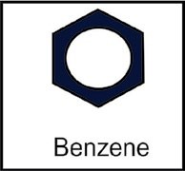In alkynes the C ≡ C bond length is 1.20A.**o** In benzene the C-C bond length is 1.397A.

The C - C bond length in benzene is intermediate between those in alkanes and alkenes. The resonating single and double bonds in benzene can better be represented as a complete circle inside the ring.

## **9.4 PREPARATION OF BENZENE**

Benzene and other aromatic hydrocarbons are readily obtained in large quantities from coal and petroleum. Benzene and some other hydrocarbons can also be obtained from petroleum by special cracking methods. Some of the methods generally used for the preparation of benzene are as follows.

1. **Dehydrogenation of Cyclohexane**

When cyclohexane or its derivative is dehydrogenated

we

get

benzene

or

a

substituted

benzene.

The

reaction

is

carried

out

by

the

use

of

a

catalyst

at

elevated

temperature.

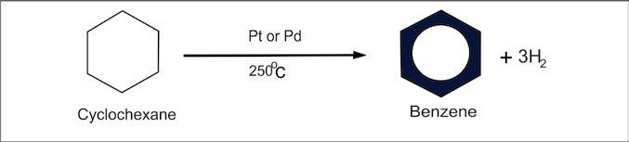

1. **From Acetylene:**

Benzene is formed by passing acetylene under pressure over an organonickel catalyst at 70°C.

17

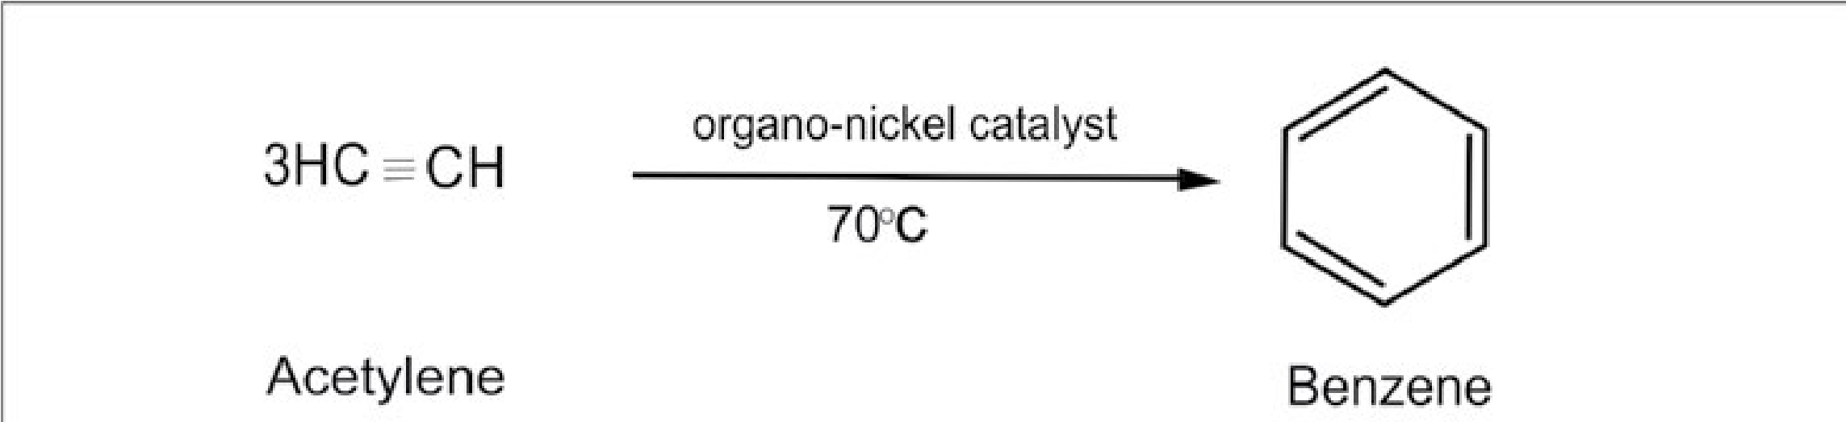

1. **FromAlkanes**

Benzene and toluene are also prepared by passing the vapours of n-haxane or n-heptane over a mixture of catalysts Cr2O3 + AI2O3 + SiO2 at 500°C.

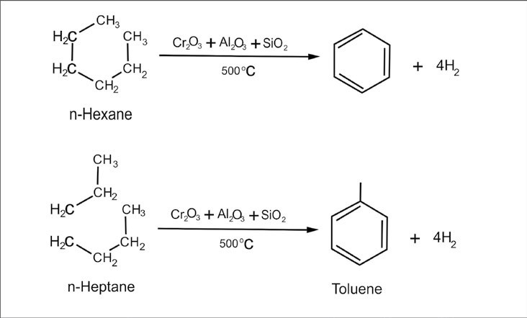

Benzene

CH

3

1. **Preparation in the Laboratory**

Benzene can be prepared in the laboratory by any one of the following methods.

i. By heating sodium salt of benzoic acid with soda lime.

18

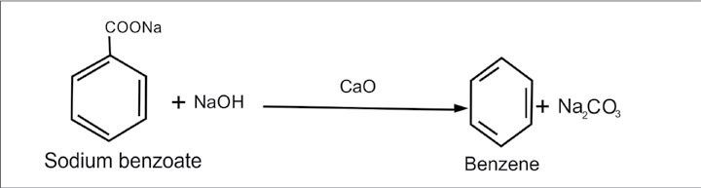

ii. By distilling phenol with zinc dust.

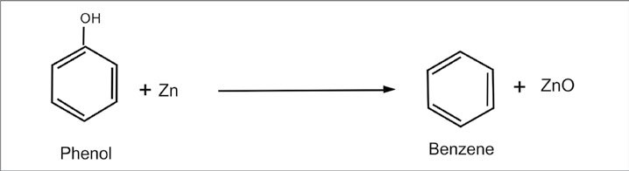

iii.

By

the

hydrolysis

of

benzenesulphonic

acid

with

superheated

steam

or

by

boiling

with

dil.

HCl.

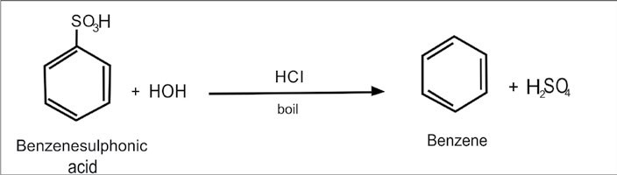

**5. Wurtz-Fittig Reaction**

The Wurtz reaction for the synthesis of alkanes was extended by Fittig in 1864 to the synthesis of alkyl aromatic hydrocarbons.

19

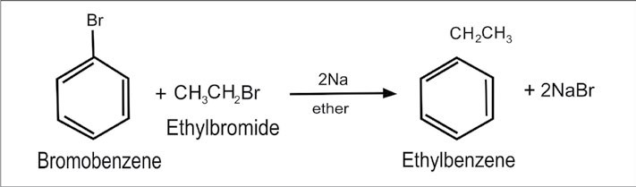

## **9.5 REACTIONS OF BENZENE**

### 9.5.1 General Pattern of Reactivity of Benzene Towards Electrophiles

The highly stable, delocalized electrons of benzene ring are not readily available for the nucleophillic attack like the electrons of alkenes.

Therefore, the electrons of benzene ring do not assist in the attack of weak electrophiles. It means that more powerful electrophiles are required to penetrate and break the continuous sheath of electron cloud in benzene, e.g., substitution of halogen in benzene requires iron or corresponding ferric halide as a catalyst. Infact iron too is first converted into FeX3 which further reacts with halogen molecule to produce a powerful electrophile.

20

2Fe+3X2 → 2FeX3

FeX3 + X2 → FeX−4 + X+

Tetra haloferrate Halogenonium ion (III) ion

The halogenonium ion X+ thus produced attacks as a powerful electrophile on the electrons of benzene ring.

*Animation 9.8 :* [*Alkenes due to resonance*](https://chemistry.boisestate.edu/richardbanks/organic/benzenealkylationtutorial1.htm)

21

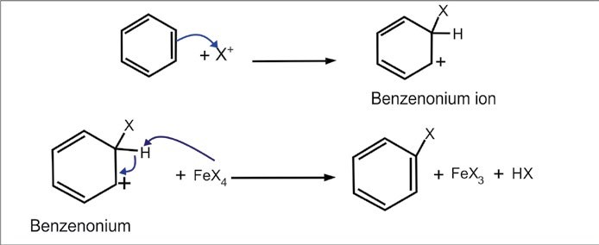

**ion**

*Source & Credit :* [*Chemistry.boisestate.edu*](https://chemistry.boisestate.edu/)

The addition product is not favourable because in its formation the characteristic stability of benzene is lost. The only possible product is the substitution product in which the stability of benzene is retained. Therefore, the general pattern of the chemical reactivity of benzene towards electrophiles can be shown as follows.

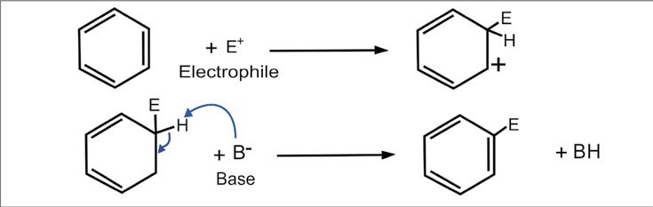

### 9.5.2 Electrophilic Substitution Reactions

#### 1. Halogenation

The introduction of halogen group in benzene ring is called “Halogenation” Benzene reacts with halogen in the presence of a catalyst like FeBr3, AlCl3, etc. Chlorination and bromination are normal reactions but fluorination is too vigorous to control. Iodination gives poor yield.

22

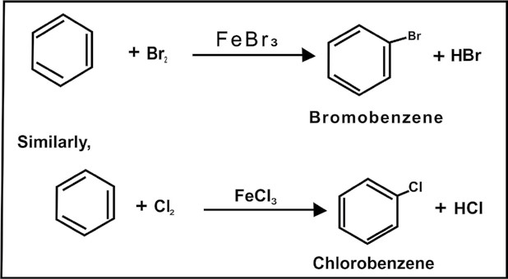

**Mechanism:**

The actual halogenating agent is X+ ( i.e. CI+ or Br+) is formed by the following mechanism.

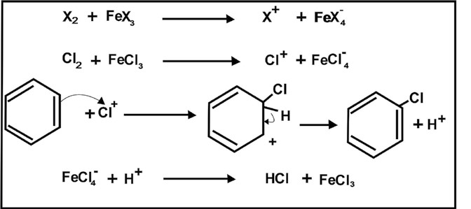

When alkyl benzenes are treated with chlorine or bromine in the presence of sunlight, only the alkyl groups are substituted.

23

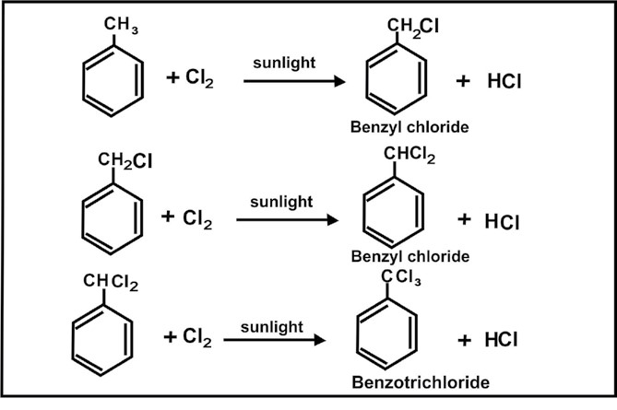

**Benzal**

#### 2. Nitration

The introduction of NO2 group in benzene ring is called “Nitration”. The nitration of benzene takes place when it is heated with a 1:1 mixture of con. HNO3 and con.H2SO4 at 50- 55°C. Sulphuric acid reacts with nitric acid to generate nitronium ion, (N02+).

24

*Animation 9.9 :*

*Nitration of benzene mechanis*

[*m*](http://sustainability.sellafieldsites.com/resources/labmouse/chemistry_a2/2602.php)

*Source & Credit :*

*Sustainability.sellafieldsite*

[*s*](http://sustainability.sellafieldsites.com/)

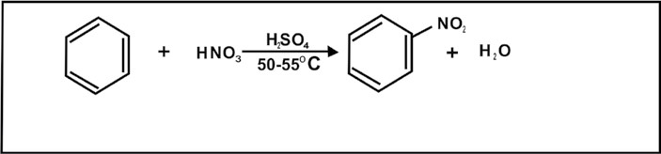

**Mechanism:**

#### 3. Sulphonation

The introduction of sulphonic acid group in benzene ring is called Sulphonation. When benzene is heated with fuming H2SO4 or conc. H2SO4 it yields benzene sulphonic acid.

## HNO +HSO2 2 4  50-550C NO +HSO +HO2+ 4- 2

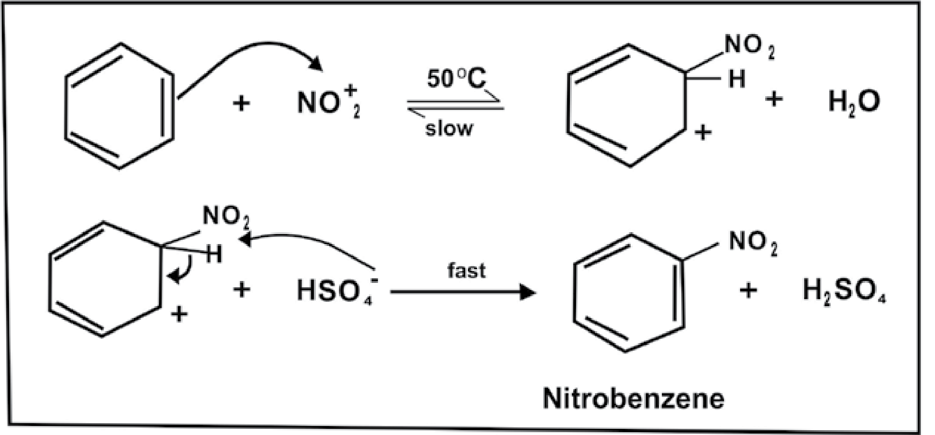

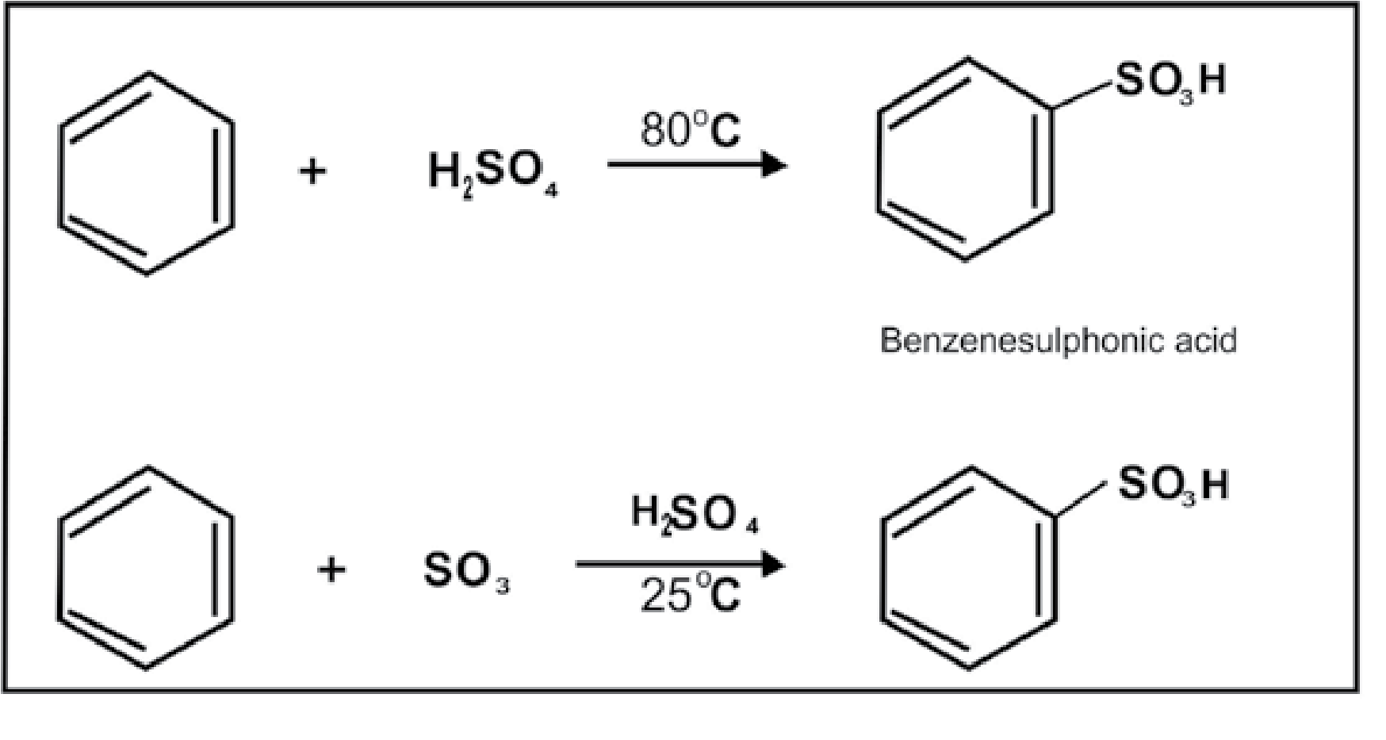

**Mechanism:**

When sulphuric acid alone is used, the actual electrophile in this reaction is SO3.

25

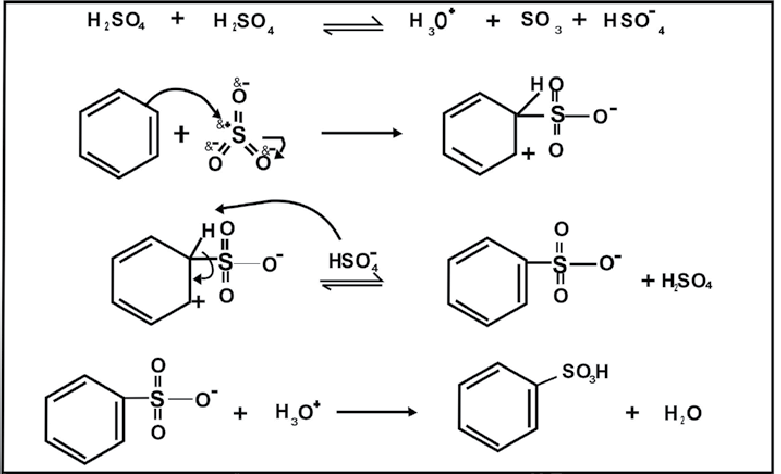

### 3. Friedel-Crafts Reactions

The alkylation and acylation of benzene are called friedel-Crafts reactions.

1. **Alkylation**

The introduction of an alkyl group in the benzene ring in the presence of an alkyl halide and a catalyst AICI3 is called Friedel-Crafts alkylation or Alkylation.

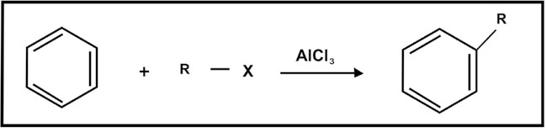

**Mechanism:**

R Cl+AlCl3 → AlCl−4 +*R*+

Carbocation

26

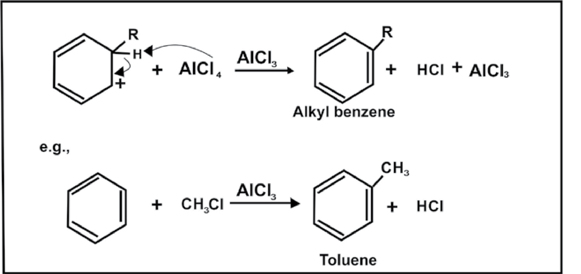

1. **Acylation:**

The introduction of an acyl group R- c in the benzene ring in the presence of an acyl halide and a catalyst AICI3 is called Friedel Crafts Acylation or Acylation.

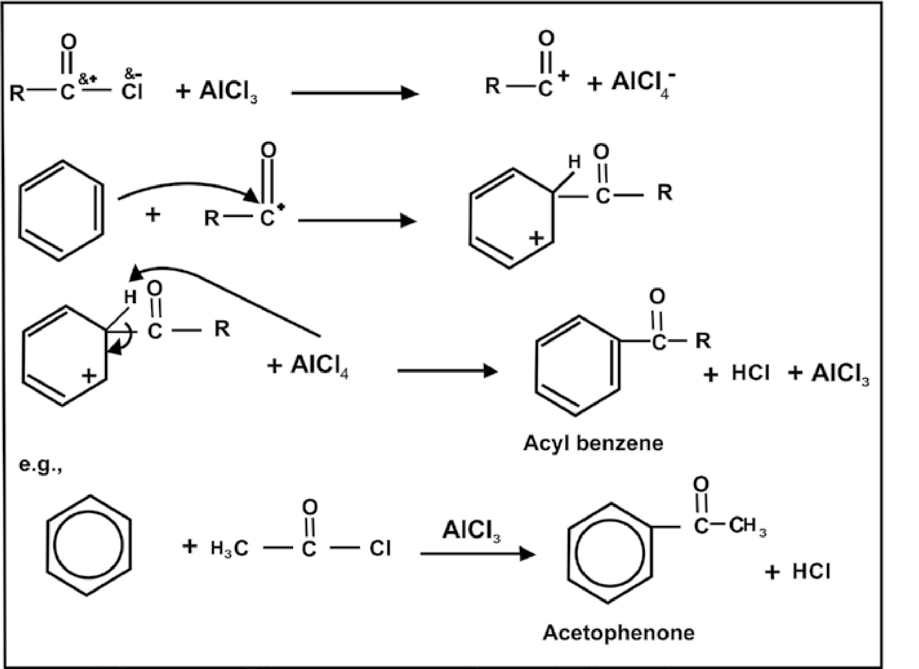

*Animation 9.10 :* [*Friedel crafts reaction*](http://friedelcraft.chez.com/web/final.htm)

*Source & Credit :* [*Friedelcraft.chez.com*](http://friedelcraft.chez.com/web/final.htm)

27

#### 9.5.3 Reactions in which Benzene Ring is Involved

**1. Addition Reactions**

**(a) Reduction:**

Benzene is reduced to cyclohexane on heating at high temperature with hydrogen in the presence of Pt in an acidic solvent (acetic acid) or Ni at 200°C as a catalyst.

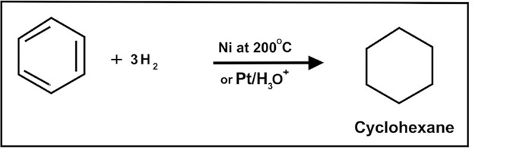

### (b) Halogenation

Benzene reacts with chlorine and bromine in the presence of sunlight to give addition products, hexachlorobenzene or hexabromobenzene. Fluorination is too vigorous while iodination is slow.

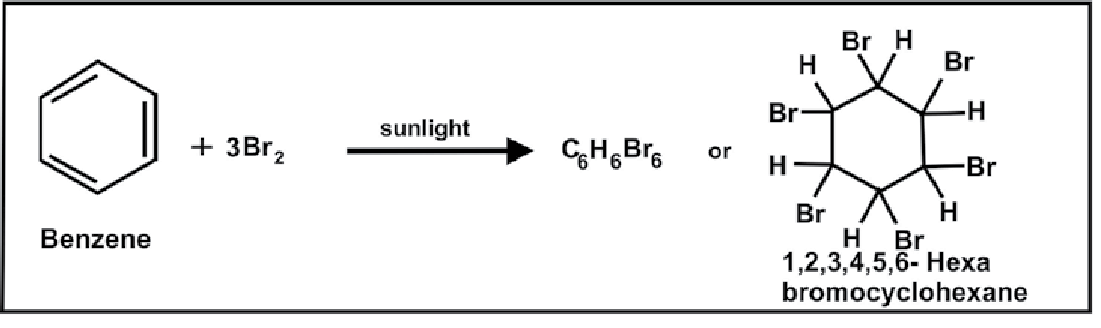

### (c) Combustion

When benzene is burnt in free supply of air, it is completely oxidized to CO2 and H2O.

### 2C H 15O6 6 + 2 →12CO 6H O2 + 2

28

#### (d) Oxidation

1. **Catalytic Oxidation**

Benzene is not oxidized by KMnO4 or K2Cr2O7 at room temperature. The ring is destroyed when benzene is strongly heated with air in the presence of V2O5 as a catalyst.

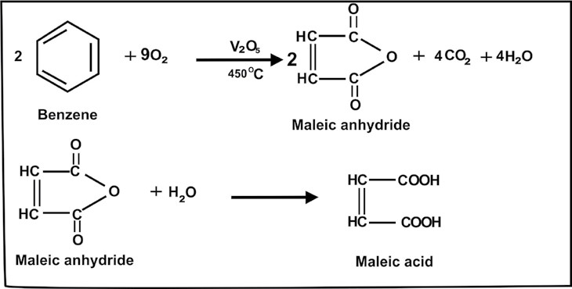

1. **Ozonolysis**

Benzene reacts with ozone and gives glyoxal through benzene triozonide.

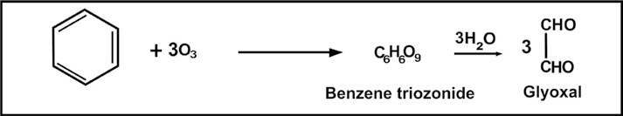

#### Side Chain Oxidation

Alkyl benzenes are readily oxidized by acidified KMnO4 or K2Cr2O7. In these reactions, the alkyl groups are oxidized keeping the benzene ring intact.

29

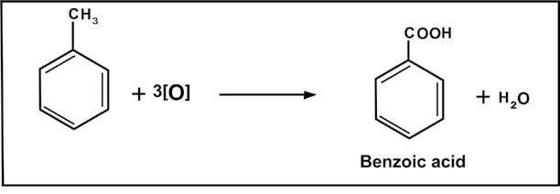

Whatever the length of an alkyl group may be it gives only one carboxyl group. Moreover the colour of KMnO4 is discharged. Therefore this reaction is used as a test for alkyibenzenes.

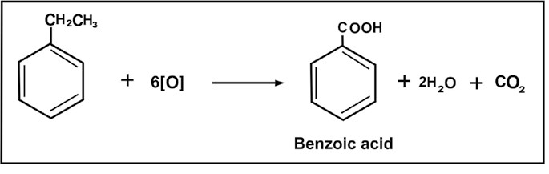

##### 9.5.4 Orientation in Electrophilic Substitution reactions

When an electrophilic substitution reaction takes place on benzene ring, we get only one monosubstituted benzene because all the six positions in the ring are equivalent. However, the introduction of a second group into the ring may give three isomeric disubstituted products, ortho, meta and para.

30

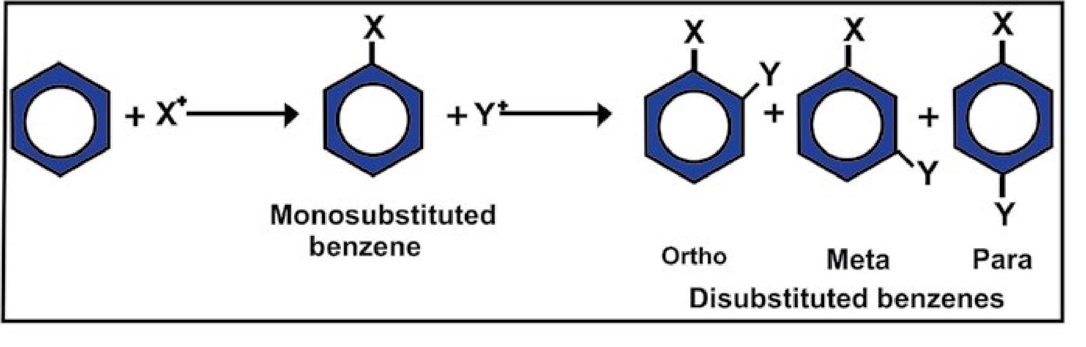

On chance basis 40% ortho, 40% meta and 20% para disubstituted products are expected.

But the actual disubstitution of benzene does not follow this principle of chance, e.g. m - Chloronitro benzene is the main product of the following halogenation reaction.

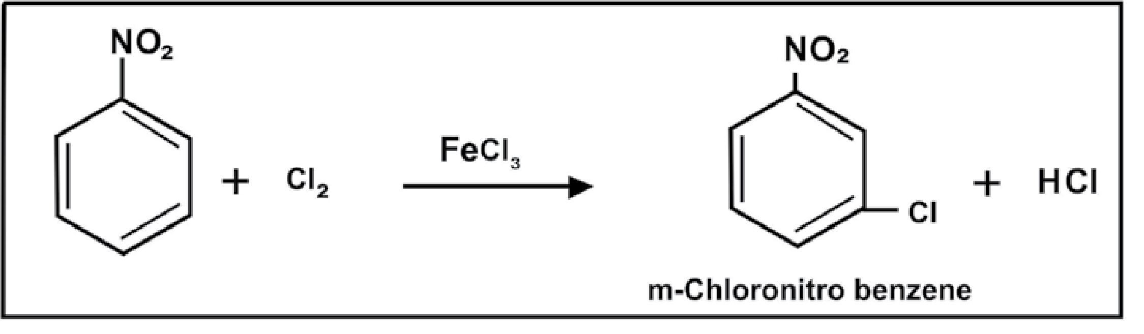

On the other hand a mixture of o- Chloronitrobenzene and p-Chloronrtrobenzene is obtained from the nitration of chlorobenzene.

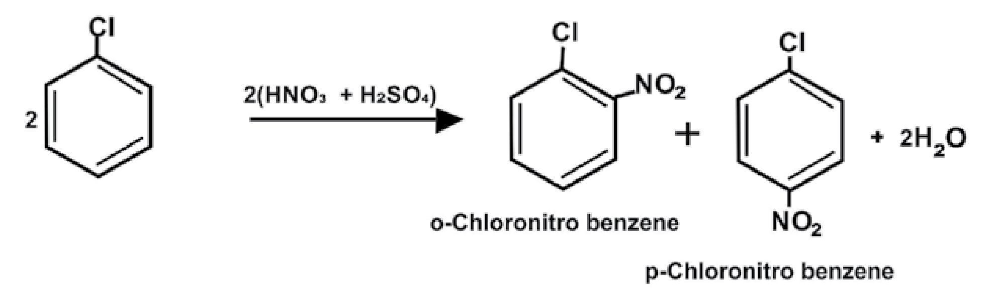

It means that the group present in the mono-substituted benzene ring has the directive effect and thus determines the position or orientation for the new incoming groups. Therefore, there are two types of groups:

1. ortho- and para- directing groups
2. meta- directing groups

##### 1. ortho and para Directing Groups

These groups release electrons to the benzene ring, thereby facilitating the availability of electrons to the electrophiles at ortho and para positions.

31

This results in the increased chemical reactivity of benzene ring towards electrophilies. The benzene ring can offer more than one positions (ortho and para) to the new incoming groups. These groups are called ortho and para directing groups, e.g.

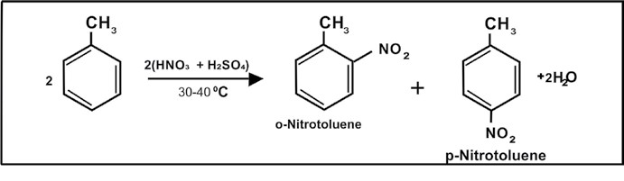

**2**

The electron releasing effect of methyl group is significant and it makes the ring a good nucleophile. Due to this increased reacivity, more nitro groups can enter the ring.

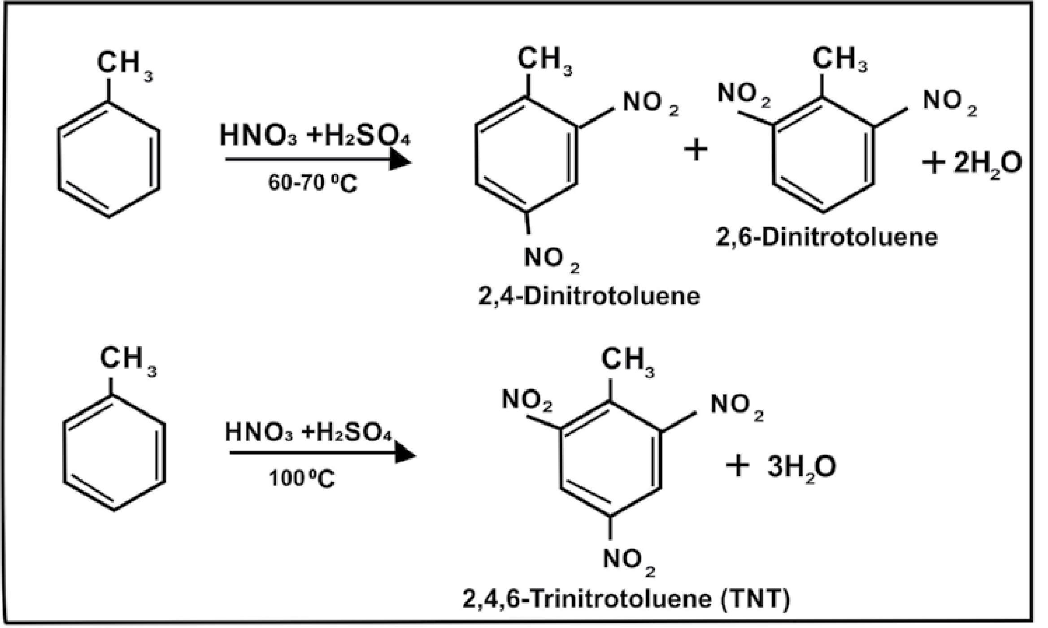

Other examples of ortho and para directing groups are:-

## −N(CH ) ,3 2 −NH , OH,2 − OCH , Cl,3 − Br, I

32

### 2. meta -Directin g Groups

These groups withdraw the electrons of the benzene ring towards themselves, thereby reducing their availability to the electrophiles.

This results in the decreased chemical reactivity of benzene. Moreover, due to the electron withdrawing effect of such substituents, the ortho and para positions are rendered more electron deficient than the meta position. Thus the incoming electrophile will prefer to attack on meta position rather than ortho and para positions. These groups are called meta-directing groups, e.g.

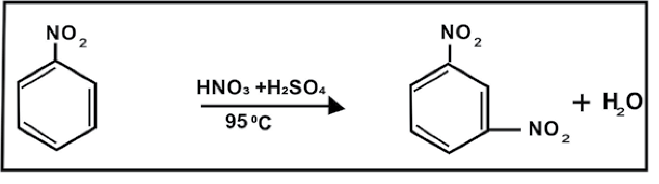

The substitution of third nitro group is not possible, other examples of meta directing groups are:

N R ,+ 3 C ≡ N, COOH, CHO, COR

### 9.6 COMPARISON OF REACTIVITIES OF ALKANES,ALKENES AND BENZENE

We have studied that alkanes are unreactive class of compounds and their unreactivity is due to their non-polar nature and the inertness of s-bond. However, they undergo substitution reactions relatively easily and these reactions involve free radicals.

Alkenes, on the other hand, are very reactive class of compounds and their reactivity is due to the inherent weakness of the π-bond and the availability of π electrons for the electrophilic reagents.

33

They undergo electrophilic addition reactions easily. Being relatively unstable, alkenes undergo polymerization reactions and they are also readily oxidized.

Benzene is unique in its behaviour. It is highly unsaturated compound and at the same time it is very stable molecule. The stability of benzene, as described earlier, is due to the extensive delocalization of π-electrons. It resembles alkenes when it gives addition reactions. The substitution of benzene, however, does not involve free radicals. These are electrophilic substitution reactions and involve electrophiles.

Its addition reactions require more drastic conditions than those for alkenes.

Benzene does not undergo polymerization and it is also resistant to oxidation.

### KEYPOINTS

1. Aromatic hydrocarbons include benzene and all those compounds that are structurally related to benzene.
2. Aromatic hydrocarbons containing one benzene ring in their molecules are called monocyclic aromatic hydrocarbons.
3. Aromatic hydrocarbons containing two or more benzene rings in their molecules are called polycyclic aromatic hydrocarbons.
4. Benzene was discovered by Michael Faraday in 1825.
5. The electrons in benzene are loosely held and the ring acts as a source of electrons. Hence benzene is readily attacked by electrophiles in the presence of a catalyst.
6. Since electrophilic substitutions reaction lead to resonance stabilized benzene derivatives so substitutions are the main reactions of benzene.
7. Resonance energy of benzene is 150.5 kJ/mole.
8. Structure of benzene is the resonance hybrid of two Kekule’s structures and three Dewar’s structures.
9. Groups like NH2, NHR, - OR, - SH, - OCOR, - X, - OH, etc. which increase the electron density in the nucleus and facilitate further electrophilic substitutions are known as ortho- and para-directing groups.
10. Groups like CN, - CHO, NH3, NR3, CCl3 which hinder further substitution in the benzene nucleus are known as meta- directing groups.

34

### EXERCISE

**Q1. Fill in the blanks.**

1. The term aromatic was derived from Greek word___________ meaning _______________.
2. Aromatic hydrocarbons include benzene and all those compounds which are ___________ related to benzene. iii) ______________is recognized as the simplest member of the class of Aromatic Hydrocarbons.
3. Benzene has_______________structure.
4. These removal of hydrogen atom from aromatic hydrocarbons gives a radical. The radicals are called__________ . vi) Benzene was discovered by Michael Faraday in_______ .

vii) The unhybridized 2pz orbitals in benzene partially overlap to form a ___________ of electron cloud. viii) The introduction of halogen group in benzene ring is called_______. ix) The molecular formula of C6H6 indicates that it is highly__________ compound.

x) On oxidation in the presence of V2O5 benzene gives__________.

**Q.2 Indicate True or False.**

1. Benzene is more reactive than alkene and less reactive than alkane.
2. Benzene has a pentagonal structure. o iii) The C-C bond length in benzene molecule is 1.397 A.

iv) The state of hybridization of carbon in benzene molecule is sp3. v) There are six sigma bonds in benzene molecule. vi) Halogenonium ion produced in electrophilic substitution reactions is a powerful electrophile. vii) In electrophilic substitution reactions, addition products are favourable. viii) Sulphonation is carried out when benzene is heated with conc. HNO3. ix) In ozonolysis benzene directly gives glyoxal.

x) Benzene has five resonace contributing structures.

**Q.3. Multiple choice questions. Encircle the correct answer.**

i) The benzene molecule contains

(a) Three double bonds (b) Two double bonds

(c) One double bond (d) Delocalized π-electron charge

35

ii) Aromatic hydrocarbons are the derivatives of

(a) normal series of paraffins (b) alkene

(c) benzene (d) cyclohexane

1. Which of the following acid can be used as a catalyst in Friedel-Crafts reactions?

(a)AlCl3 (b) HNO3 (c)BeCl2 (d)NaCl

1. Benzene cannot undergo

(a) substitution reactions (b) addition reactions

(c) oxidation reactions (d) elimination reactions

v) Amongst the following, the compound that can be most readily sulphonated is

(a) toluene (b) benzene (c) nitrobenzene (d) chlorobenzene

1. During nitration of benzene, the active nitrating agent is

(a)NO3 (b)NO2+ (c)NO2- (d)HNO3

1. Which compound is the most reactive one:

(a) benzene (b) ethene (c) ethane (d) ethyne

viii) The electrophile in aromatic sulphonation is:

(a)H2SO4 (b)HSO4 (c) SO3 (d) SO3+ ix) Aromatic compounds burn with sooty flame because:

1. They have high percentage of hydrogen.
2. They have a ring structure.
3. They have high percentage of carbon.(d) They resist reaction with air.

x) The conversion of n-hexane into benzene by heating in the presence of Pt is called:

(a) Isomerization (b) Aromatization

(c) Dealkylation (d) Rearrangement

36

Q. 4. What are aromatic hydrocarbons? How are they classified?

Q. 5. What happens when:

1. Benzene is heated with conc. H2SO4 at 250°C.
2. Chlorine is passed through benzene in sunlight.
3. A mixture of benzene vapours and air are passed over heated vanadium pentoxide.
4. Benzene is burnt in free supply of air.

Q.6. What is meant by the terms:

i) Aromatic ii) Oxidation iii) Sulphonation iv) Nitration v) Halogenation

Q. 7. (a) Draw structural formulas for the following compounds.

i) m-Chlorobenzoic acid vi) 2,4,6 Trinitrotoluene ii) p-Hydroxybenzoic acid vii) m-Nitrophenol iii) o-Bromonitrobenzene viii) p-Dibenzylbenzene

1. o-Ethyltoluene ix) 2-Amino-5-bromo-3 nitrobenzenesulphonic acid
2. p-Nitroaniline

(b) Give names and the possible isomeric structuresof the following.

i) Xylenes ii) Trimethylbenzene iii) Bromonitrotoluene

Q. 8. Write IUPAC names of the following molecules.

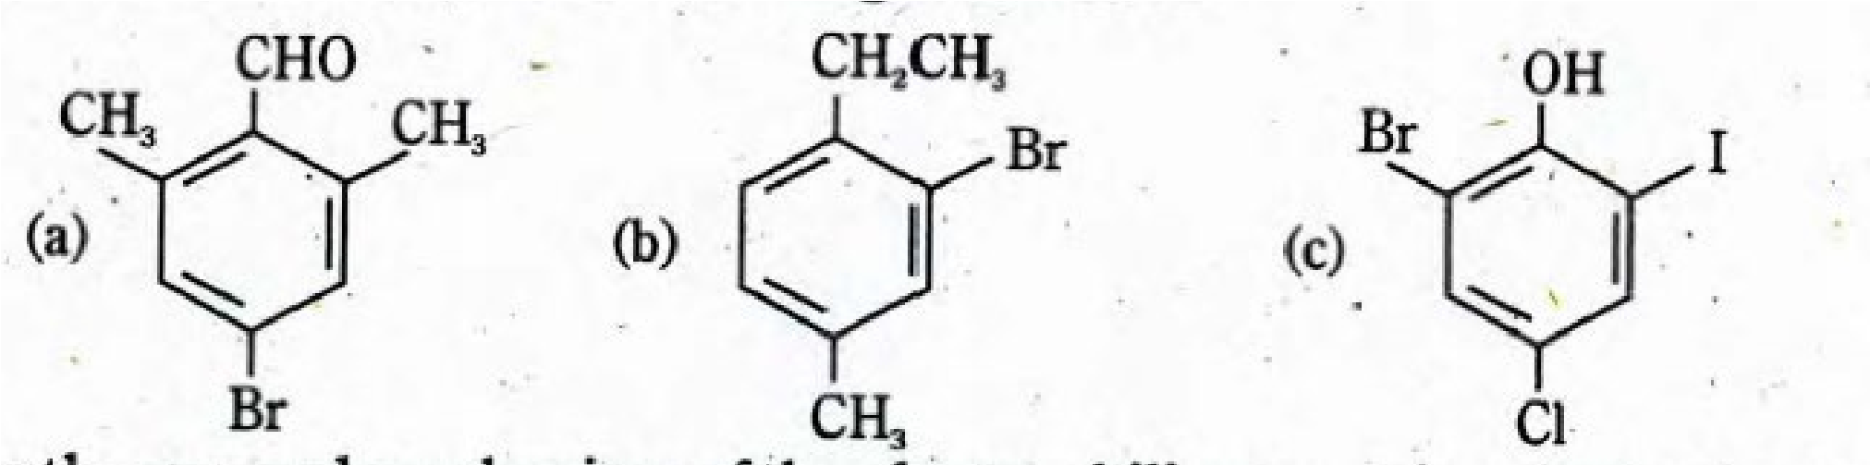

Q. 9. Give the general mechanism of the electrophilic aromatic substitution reactions.

Q. 10. (a) Describe the structure of benzene on the basis of following.

i) Atomic orbital treatment ii) Resonance method (b) Prove that benzene has a cyclic structure.

37

Q. 11. Predict the major products of bromination of the following compounds.

(a) Toluene (b) Nitrobenzene (c) Bromobenzene (d) Benzoic acid (e) Benzaldehyde (f) Phenol

Q. 12. How will you prepare the following compounds from benzene in two steps.

1. m-chloronitrobenzene
2. p-chloronitrobenzene

Q. 13. Complete the following reactions. Also mention the conditions needed to carry out these reactions.

38

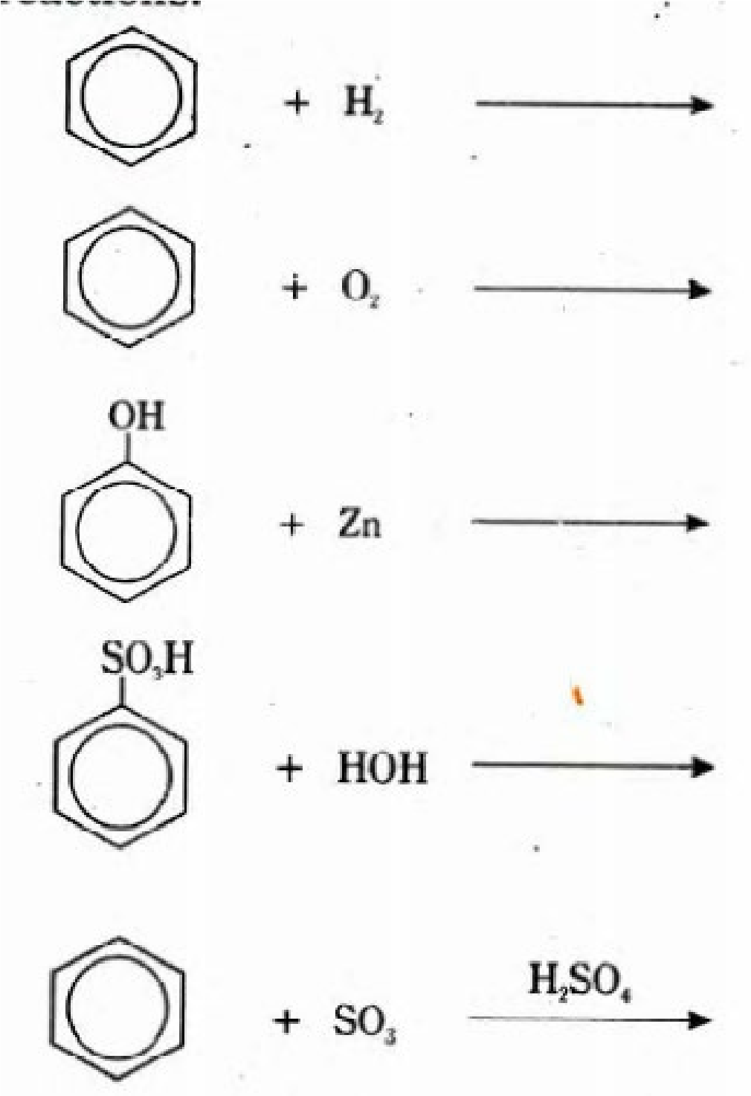

Q. 14. Detail out three reactions in which benzene behaves as if it is a saturated hydrocarbon and three reactions in which it behaves as if it is unsaturated.

Q. 15. What are Frediel-Crafts reactions. Give mechanism with example of the following reactions.

i) Friedel-Crafts alkylation reactions ii) Friedel-Crafts acylation reactions.

## CHAPTER10 ALKYL HALIDES

*Animation 10.1:* [*Alkyl Halides reaction*](http://chemwiki.ucdavis.edu/@api/deki/files/7389/=sn2.gif?revision=1&size=bestfit&width=272&height=204)

*Source & Credit:* [*chemwiki*](http://chemwiki.ucdavis.edu/)

**IN THIS CHAPTER YOU WILL LEARN:**

1. How to name an alkyl halide and to classify it into primary, secondary and tertiary alkyl halides.
2. Simple ways of generating alkyl halides.
3. The reason why C-X bond in chemistry is one of the most reactive type.
4. The general mechanistic details of nucleophilic substitution and elimination reactions.
5. The preparation of Grignard’s reagent, the reactivity of C-Mg bond and its synthetic applications in organic chemistry.

### 10.1 INTRODUCTION

Halogen derivatives of alkanes are called haloalkanes. They may be mono, di, tn or poly haloalkanes depending upon the number of halogen atoms present in the molecule.

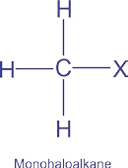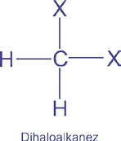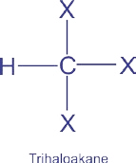

Among these, monohaloalkanes are also called Alkyl Halides. Their general formula is R -- X , where R may be methyl, ethyl, propyl, etc. and X represents halogen atoms (F, Cl, Br, I). Mono haloalkanes or alkyl halides are further classified into primary, secondary and tertiary alkyl halides depending upon the type of carbon atom bearing the halogen atom.

In a primary alkyl halide halogen atom is attached with a carbon which is further attached to one or no carbon atom e.g.,

#### CH3 CI CH3 CH2 CI CH3 CH2 CH2 CI

Chloromethane Chloroethane 1-Choropropane

Secondary alkyl halides are those in which halogen atom is attached with a carbon atom which is further attached to two other carbon atoms directly, e.g., secondary carbon atom.

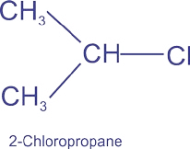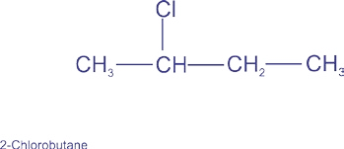

In tertiary alkyl halides halogen atom is attached to a carbon which is further attached to three carbon atoms directly.

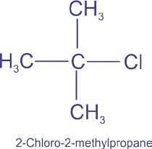

### 10.2 NOMENCLATURE OF ALKYL HALIDES

#### COMMON NAMES

|  |
| --- |
| 2 3 |

Alkyl halides (monohaloalkanes) are named according to the nature of the alkyl group to which halogen atom is attached. For example,

CH3  CI CH3  CH2 Br CH3  CH2 CH2 Br

Methyl chloride Ethyl bromide n-Propyl bromide

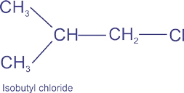CH3  CH2 CH2 CH2 Cl n-Butylchloride

#### IUPA C Nomenclature

The systematic names given to alkyl halides follow the underlying rules.

1. Select the longest continuous carbon chain and consider the compound to have been derived from this structure.
2. Number the carbon atoms in the chain so that the carbon atom bearing the functional group (F, Cl, Br, I) gets the lowest possible number, e.g.,

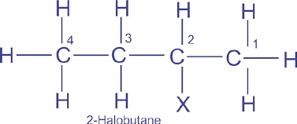

1. If the same alkyl substituent occurs more than once on the chain, the prefix di, tri and so on are used before the name of the alkyl group.
2. The positions of the substituents are indicated by the appropriate numbers separated by commas. If the same substituent occurs twice or more on the same carbon atom the number is repeated.

Examples which follow the above mentioned rules:

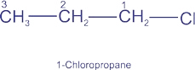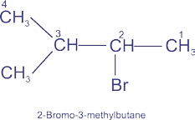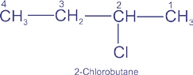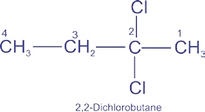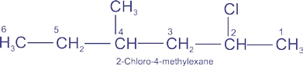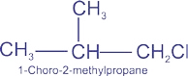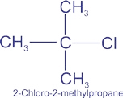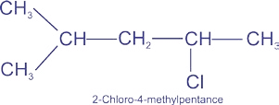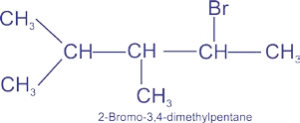

### 10.3 METHODS OF PREPARATION OF ALKYL HALIDES

|  |
| --- |
| 4 5 |

Alkyl halides can be prepared by the halogenation of alkanes and by the addition of halogen acids to alkenes. These methods have already been discussed in the previous chapters. The best method for the preparation of alkyl halides is from alcohols.

#### 1. From Alcohols

**(a)** Reaction of alcohols with halogen acids.

Alcohols may be converted to the corresponding alkyl halides by the action of halogen acid in the presence of ZnCl2 which acts as a catalyst.

### CH3 CH2 OH + HX ZnCl CH3 CH2 X + H2O

2

#### Ethyl halide

1. Alcohols also react with thionyl chloride in pyridine as a solvent to give alkyl chlorides. This method is especially useful since the by-products (HC1, SO2) are gases, which escape leaving behind the pure product. ROH+ SOCl2 Pyridine R Cl + SO2 + H2O
2. Phosphorus trihalides or phosphorus pentahalides react with alcohols to replace -OH group by a halo group.

3CH3  CH2 OH + PBr3 3CH3  CH2 Br + H3PO3

CH3  CH2 OH + PCl5 CH3  CH2 Cl + POCl3 + HCl

**2.** An excellent method for the preparation of simple alkyl iodide is the treatment of alkyl chloride or alkyl bromide with sodium iodide. This method is particularly useful because alkyl iodides cannot be prepared by the direct iodination of alkanes.

RCl Nal Rl + NaCl

RBr Nal Rl + NaBr

#### 10.4 REACTIVITY OF ALKYL HALIDES

An alkyl halide molecule (R — X) consists of two parts, an alkyl group with a partial positive charge on the carbon atom attached to halogen atom and the halide atom with a partial negative charge.

There are two main factors which govern the reactivity of R — X bond.

These are:

i) C— X Bond energy ii) C— X Bond polarity

##### Bond Energy

The following table shows the bond energies of C— X bonds in alkyl halides.

The strength of the bonds show that iodo compound (with the weakest bonds) would be the most reactive one while fluoro compound will be the least reactive i.e., the order of reactivity of alkyl halides should be R— I > R— Br > R— Cl > R— F

##### Bond Polarity

|  |  |
| --- | --- |
| **Bond** | **Bond Energy**  **(kj/mole)** |
| C — F  C — H  C — Cl  C — Br  C — I | 467  413  346  290  228 |

Electronegativities of halogen, carbon and hydrogen atoms present in alkyl halides are shown in the table.

The greatest electronegativity difference exists between carbon and fluorine atoms in alkyl fluorides.

|  |  |
| --- | --- |
| **Atom** | **Electronegativity** |
| F  Cl  Br  I  H  C | 4.0 3.0 2.8 2.5 2.1  2.5 |

If an electrophile is the attacking reagent then this difference suggests that alkyl fluorides would be the most reactive one. On the same lines, alkyl iodides should be the least reactive alkyl halides.

In the light of the above discussion it is clear that the two factors mentioned above predict different types of behaviour about the reactivity of alkyl halides.

Experiments have shown that the strength of carbon halogen bond is the main factor which decides the reactivity of alkyl halides.

So the overall order of reactivity of alkyl halides for a particular alkyl group is:

|  |
| --- |
| 6 7 |

Iodide > Bromide > Chloride > Fluoride In fact the C-F bond is so strong that alkyl fluorides do not react under ordinary conditions.

#### 10.5 REACTIONS OF ALKYL HALIDES

The reactions of alkyl halides fall into two categories.

1. Those reactions in which the halogen is replaced by some other atom or a group (nucleophilic substitution, or SN reactions).
2. Tnose which involve the removal of HX from the nanae (elimination, or E reactions).

##### 10.5.1 Nucleophilic Substitution Reactions

Before discussing specifically the nucleophilic substitution reactions (SN) of alkyl halides, let us look at the nucleophilic reaction in general. The overall process describing an SN reaction is shown as follows:

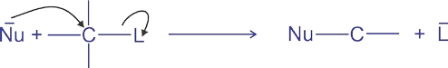

In this equation the incoming group Nu is a nucleophile. Nucleophile means nucleus loving. It has an unshared electron pair available for bonding and in most cases it is basic in character. It may be negatively charged or neutral.

##### Examples of Nucleophiles

|  |  |  |  |
| --- | --- | --- | --- |
| HO-  C2H5O-  H SSCN-  H2O:  NH - | Hydroxide ion  Ethoxide ion  Hydrogen sulphide ion  Thiocyanate ion  Water  Amino group | CIBr-  :  NH3  CN-  I- | Chloride ion  Bromide ion  Ammonia  Cyanide ion  Iodide ion |

2

:

##### Electrophile

It is a specie which attracts electrons (electron loving). The carbon atom of an alkyl group attached with the halogen atom and bearing a partial positive charge is called an electrophile or electrophilic center. An electrophile may be neutral or positively charged.

*Animation 10.3:* [*Electrophilic addition*](http://www.johnwiley.net.au/highered/chemistry/molvis/xx-electrophilic.swf)

*Source & Credit:* [*johnwiley*](http://www.johnwiley.net.au/)

###### Leaving Group

L is also a nucleopile. It is called leaving group because it departs with an unshared pair of electrons. If we wish a SN reaction to proceed in the forward direction the incoming nucleophile must be stronger than the departing one. Cl- , Br- , I- , HSO4- are good leaving groups. Poor leaving groups are OH- , and NH OR 2-. Iodide ion is a good nucieophile as well as a good leaving group.

###### Substrate Molecule

The alkyl halide molecule on which a nucleophile attacks is called a substrate molecule.

###### 10.5.2 Mechanism of Nucelophilic Substuitution Reactions

Alkyl halides may undergo nucleophilic substitution reactions in two different ways:

1. Nucleophilic Substitution Bimolecular (SN2)
2. Nucleophilic Substitution Unimolecular (SN1)

8 9

Nucleophilic substitution reactions on alkyl halides involve two main processes, the breakage of C — X bond and the formation of C — Nu bond. The mechanism of the nucleophilic substitution reactions depends upon the timing of these two processes.

If the two processes occur simultaneously the mechanism is called SN2 . If the bond breaks first followed by the formation of a new bond, the mechanism is called SN1. **Nucleophilic Substitution Bimolecular (SN2)**

This is a single step mechanism. As soon as the nucleophile starts attacking the electrophilic carbon of the substrate, the bond with which the leaving group is attached, starts breaking. In other words the extent of bond formation is equal to the extent of bond breakage.

Another important feature of this mechanism is the direction of the attack of the attacking nucleophile. It attacks from the side which is opposite to the leaving group.

In order to give to the nucleophile enough room to attack, the substrate carbon atom changes its state of hybridization from tetrahedral sp3 to planar sp2. The attack of the nuclephile, the change in the state of hybridization and the departure of the leaving group, every thing occurs at the same time.

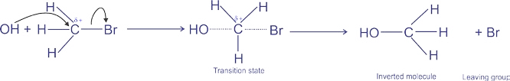

During the reaction the configuration of the alkyl halide molecule gets inverted. This is called inversion of configuration.

Molecularity of a reaction is defined as the number of molecules taking part in the rate determining step. Since in this mechanism, the reaction takes place in only one step which is also a rate determining step and two molecules are participating in this step, so it is called a bimolecular reaction.

Kinetic studies of the reactions involving SN2 mechanism have shown that the rates of such reactions depend upon the concentrations of alkyl halide as well as the attacking nucleophile. Mathematically, the rate can be expressed as:

10

11

Rate = k [Alkyl halide]1 [Nucleophile]1

Since the exponents of the concentration terms in the above expression are unity, so the order of a typical SN2 reaction will be 1 + 1 = 2. Among the alkyl halides, the primary alkyl halides always follow SN2 mechanism whenever they are attacked by nucleophiles.

##### Nucleophilic Substitution Unimolecular (SN1)

This type of mechanism involves two steps. The first step is the reversible ionization of the alkyl halide in the presence of an aqueous acetone or an aqueous ethyl alcohol. This step provides a carbocation as an intermediate. In the second step this carbocation is attacked by the nucleophile to give the product.

**First Step:**

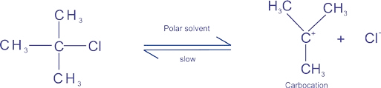

**Second Step:**

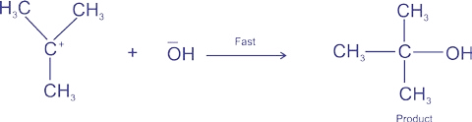

Since the first step involves the breakage of a covalent bond so it is a slow step as compared to the second step which involves the energetically favourable combination of ions. The first step is, therefore, called the rate-determining step. The mechanism is called unimolecular because only one molecule takes part in the rate determining step.

In SN1 mechanism, the nucleophile attacks when the leaving group had already gone, so the question of the direction of the attack does not arise. Moreover, the intermediate carbocation is a planar specie allowing the nucleophile to attack on it from both the directions with equal ease. We, therefore, observe 50% inversion of configuration and 50% retention of configuration.

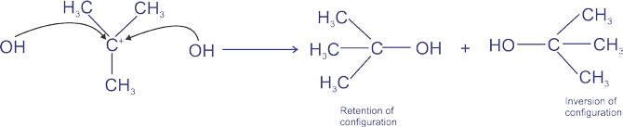

Reactions involving SN1 mechanism show first order kinetics and the rates of such reactions depend only upon the concentration of the alkyl halide. The rate equation of such reactions can be written as follows. Rate = k [Alkyl halide]

Tertiary alkyl halides when attacked by a nucleophile always follow SN1 mechanism. Secondary alkyl halides, on the other hand, follow both SN1 and SN2 mechanisms.

###### 10.5.3 b-Elimination Reactions

During nucleophilic substitution reactions, the attacking nucleophile attacks the electrophilic carbon atom of the alkyl halide. There is another site present in the alkyl halide molecule where the nucleophile can attack at the same time.Such a site is an electrophilic hydrogen atom attached to the b-carbon of the alkyl halide.

When the attack takes place on hydrogen, we get an alkene instead of a substitution product. Such a type of reactions are called elimination reactions.

These reactions take place simultaneously with substitution reactions and often compete with them.

12

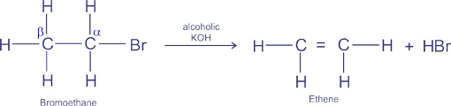

Like nucleophilic substitutions, the elimination reactions can also follow E2 or E1 mechanism.

In E2 mechanism, the nucleophile attacks and the leaving group leaves at the same time with a formation of carbon carbon double bond.

13

The single step E2 elimination

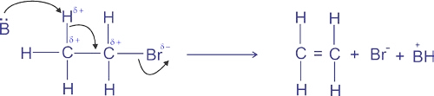

Like SN2 reactions, the molecularity of E2 reactions is also two and these reactions show second order kinetics.

In E1 mechanism, like SN1 mechanism, the first step is the slow ionization of the substrate to give a carbocation. In the second step, the nucleophile attacks on hydrogen to give an alkene as a product

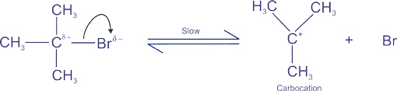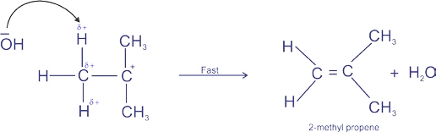

E2 mechanism is a bimolecular mechanism and the rates of those reactions which follow this mechanism depend upon the concentrations of the alkyl halide as well as the attacking nucleophile or a base. E1 mechanism, on the other hand, is a unimolecular mechanism and the rates of those reactions which follow this mechanism depend only upon the concentration of the alkyl halide molecule. Primary alkyl halides generally follow E2 mechanism whereas tertiary alkyl halides follow E l mechanism.

Examples of SN reactions are given below.These reactions show the usefulness of alkyl halides as synthetic reagents.

**Substrate Attacking Nucleophile**

δ+ δ−

CH3 CH2 Br + OH δ+ δ− − CH3 CH2 Br + I

δ+ δ− −

CH3 CH2 Br + CN δ+ δ− − CH3 CH2 Br + NO2

δ+ δ− −

CH3 CH2 Br + CH3O

δ+δ−

**.**

**.**

CH3 CH2 Br + NH3

δ+ −

NH

**.**

**.**

δ

CH3 CH2 Br + CH3 CH2 2

δ+ δ−

CH3 CH2 Br + (CH3 CH2)2 NH

**.**

**.**

δ+ δ−

CH3 CH2 Br + (CH3 CH2)3 N

**.**

**.**

δ+ δ−

CH3 CH2 Br + SH  δ+ δ− − CH3 CH2 Br + CH3COO Na+

Product

C2H5OH + Br−

Ethyl alcohol

C2H5I + Br−

Ethy liodide

C2H5CN + Br−

Propane nitrile

C2H5NO2 + Br −

Nitroethane

CH3 CH2 O CH3 + Br−

Ethyl methyl ether

C2H5 NH2 + HBr

Ethylamine

(CH3 CH2)2NH + HBr

Diethylamine

(CH3 CH2)3N + HBr Triethylamine

(CH3 CH2)4N + Br−

Quaternary ethylammonium ion

−

C2H5SH + Br

Ethyl thioalcohol

CH3COOC2H5 + NaBr Ethyl acetate

1. Wurtz Synthesis

Alkyl halides react with sodium in ether solvent to give alkanes. The reaction is particularly useful for the preparation of symmetrical alkanes.

CH3 CH2 Cl + 2Na + Cl CH2 CH3 Ether CH3 CH2 CH2 CH2 CH3+ 2NaCl

n-Butane

2. Reduction of Alkyl Halides

Alkyl halides can be reduced with zinc in the presence of an aqueous acid such as HCI or CH3COOH.

CH3 CH2 CH2 Cl + Zn + H+ + Cl CH3 CH2 CH3 + ZnCl2

#### Propane

##### 3. Reaction with Sodium Lead Alloy (Na4Pb)

Methyl chloride and ethyl chloride react with sodium lead alloy giving tetramethyl lead and tetraethyl lead,respectively. These compounds are important anti-~~k~~nock agents and are used in gasoline.

4CH3Cl + Na4Pb (CH3)4Pb + 4NaCl

Tetramethyl lead

4CH3CH2 Cl + Na4Pb (CH3CH2)4Pb + 4NaCl

Tetramethyl lead

##### 10.6 GRIGNARD REAGENT

Grignard reagents RMgX are derivatives of alkyl halides belonging to class of organo-metallic compounds. Grignard reagent was first prepared by Victor Grignard in 1900. These reagents are so important in organic synthesis that almost all the classes of organic compounds can be prepared from them. Due to their importance and applications Victor Grignard was awarded Nobel prize in chemistry.

15

Other reactions shown by alkyl halides are as follows:

14

**Preparation:**

Grignard reagents are prepared by the reaction of magnesium metal with alkyl halides in the presence of dry ether (alcohol free, moisture free).

δ+δ−

R X + Mg R Mg X

CH3 CH2 Br + Mg Ether CH3 CH2 Mg Br

Ether

###### Ethyl magnesium bromide

It is important that all the reactants must be absolutely dry and pure because Grignard reagents are so reactive that they may react with moisture or any impurity present. Reactivity of alkyl halides with magnesium is in the following order: Alkyl iodide > Alkyl bromide > Alkyl chloride

And for a given halogen the order of reactivity is as follows: CH3X > C2H5X > C3H7X **Structure and Reactivity**

Grignard reagents are much reactive than most of the organic compounds.

The reactivity is due to the nature of C - Mg bond which is highly polar.

δ- δ δ+ CH CH -Mg-X

3 2

Magnesium is more electropositive than carbon and the C-Mg bond though covalent is highly polar, giving alkyl carbon the partial negative charge. This negative charge is an unusual character which makes the alkyl groups highly reactive towards electrophile centres. Mostly reactions shown by Grignard reagent are exothermic. **Reactions**

1. **With Water**

16

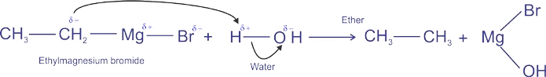

1. 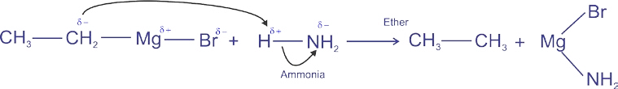**With ammonia**
2. 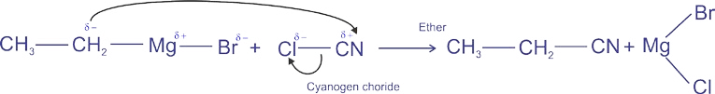**With cyanogen chloride**
3. 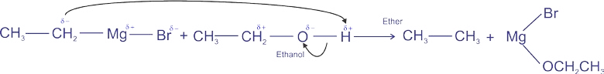**With alcohols**
4. 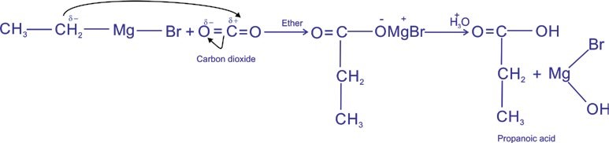**With CO2**
5. **With HCHO**

17

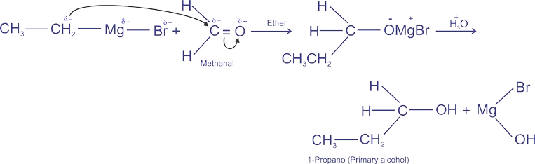

1. **With CH3CHO**

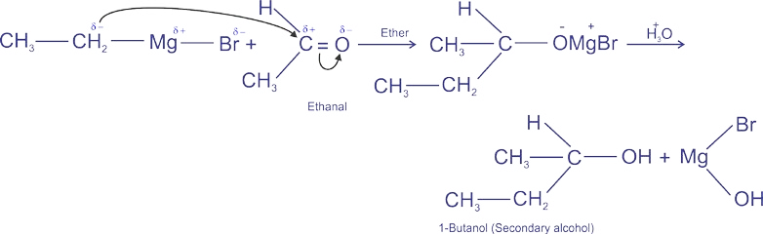 *Simulation 10.3:* [*Interactive Periodic Table*](http://www.learnerstv.com/animation/chemistry/NEWperiodic.swf)

*Source & Credit*[*: learnerstv*](http://www.learnerstv.com/index.php)

18

19

1. **With CH3COCH3**

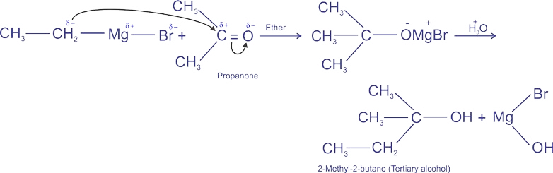

1. **With Epoxide**

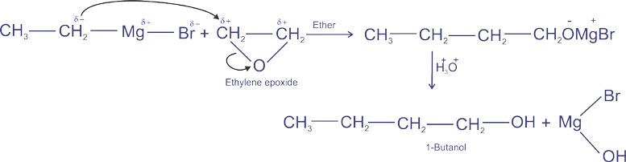

##### KEY POINTS

1. Monohalo derivates of alkanes are called alkyl halides.
2. The general formula of alky 1 halides is CnH2n +1X.
3. The best method for the preparation of alkyl halides is by the reactions of alcohols with inorganic halides like SOCl2, PX3 and PX5.
4. Alkyl halides are very reactive class of organic compounds. They undergo nucleophilic substitution reactions and elimination reactions in the presence of a nucleophile or a base.
5. Nucelophilic substitution reactions can take place in two distinct ways. A one step mechanism is called SN2 while a two step mechanism is called SN1. SN1 reactions show first order kinetics whereas SN2 reactions show 2nd order kinetic.
6. Nucleophilic substitution reactions take place simultaneously with elimination reactions and often compete with them.
7. Elimination of two atoms or groups from adjacent carbon atoms in the presence of a nucleophile or a base is called elimination reaction. Like nucleophilic substitution, (3-elimination reaction also take place in two distinct ways E2 and E1.
8. Grignard reagent can be prepared by adding alkyl halide in a stirred suspension of magnesium metal in diethyl ether.
9. Grignard reagent has a reactive nucleophilic carbon atom which can react with electrophilic centres to give the products in high yields.
10. Primary, secondary and tertiary alcohols can be best prepared by reacting Grignard reagent with formaldehyde, any other aldehydes and ketones, respectively.

###### EXERCISE

**Q.1. Fill in the blanks.**

1. In tertiary alkyl halides the halogen atom is attached to a carbon which is further attached to __________ carbon atoms directly.
2. The best method for the preparation of alkyl halides is the reaction of _________ with inorganic reagents.

20

1. An alkyl group with a partial positive charge on the carbon atom is called____________ centre.
2. The mechanism is called __________if it involves one molecule in the ratedetermining step.
3. Molecularity of a reaction is defined as the number of molecules taking part in the ______________.
4. The molecularity of E2 reactions is always two and the reactions show ________ order kinetics. vii) Wurtz synthesis is useful for the preparation of____________ alkanes. viii) Grignard reagents are prepared by the reaction of magnesium metal with alkyl halides in the presence of___________. **Q.2. Indicate True or False.**

i) In secondary alkyl halides, the halogen atom is attached to a carbon which is further attached to two carbon atoms directly. ii) Alcohols react with thionyl chloride in ether as solvent to give alkyl halides. iii) Order of reactivity of alkyl halides for a particular alkyl group is:

Iodide > Bromide > Chloride > Fluoride iv) In SN2 reactions the attacking nucleophile always attacks from the side in which the leaving group is attached.

v) Methyl magnesium iodide on hydrolysis yields ethyl alcohol. vi) Primary, secondary and tertiary amines react with Grignard reagents in the sameway.

vii) The reactions of secondary alkyl halides may follow both SN1 and SN2 mechanisms. viii) SN1 mechanism is a one stage process involving a simultaneous bond breakage and bond formation. ix) In b-elimination reactions, the two atoms or groups attached to two adjacent carbon atoms are lost under the influence of an electrophile.

x) The reactivity order of alkyl halides is determined by the strength of carbon halogen bond.

21

**Q. 3. Multiple choice questions. Encircle the correct answer.**

1. In primary alkyl halides, the halogen atom is attached to a carbon which is further attached to how many carbon atoms.
   1. Two (b) Three (c) One (d) Four
2. The reactivity order of alkyl halides for a particular alkyl group is:
   1. Fluoride > Chloride > Bromide > Iodide
   2. Chloride > Bromide > Fluoride > Iodide
   3. Iodide > Bromide > Chloride > Fluoride (d) Bromide > Iodide > Chloride > Fluoride
3. When CO2 is made to react with ethyl magnesium iodide, followed by acid hydrolysis, the product formed is:
   1. Propane (b) Propanoic acid (c) Propanal (d)

Propanol iv) Grignard reagent is reactive due to:

(a) the presence of halogen atom (b) the presence of Mg atom (c) the polarity of C -Mg bond (d) none of the above

1. SN2 reactions can be best carried out with:

(a) Primary alkyl halides (b) Secondary alkyl halides

(c) Tertiary alkyl halides (d) All the three

1. Elimination bimolecular reactions involve:

(a) first order kinetics (b) second order kinetics

(c) third order kinetics (d) zero order kinetics

1. For which mechanisms, the first step involved is the same.

(a) E1 and E2 (b)E2andSN2 (c)SN1andE2 (d) E1 and

SN1

1. Alkyl halides are considered to be very reactive compounds towards nucleophiles, because:
   * 1. they have an electrophilic carbon
     2. they have an electrophilic carbon and a good leaving group
     3. they have an electrophilic carbon and a bad leaving group
     4. they have a nucleophilic carbon and a good leaving group

22

1. The rate of E1 reaction depends upon: (a) the concentration of substrate
   * 1. the concentration of nucleophile
     2. the concentration of substrate as well as nucleophile
     3. None of the above
2. Which one of the following is not a nucleophile :

(a) H2O (b) H2S (c) BF3 (d) NH3

* 1. Define alkyl halide. Which is the best method of preparing alkyl halides?
  2. Write down a method for the preparation of ethyl magnesium bromide in the laboratory?
  3. Give IUPAC names to the following compounds.

|  |  |
| --- | --- |
| i)  iii) | ii)  iv) **(**CH3)3C CH2 Cl |
| v) **(**CH3)2CHBr | vi) **(**CH3)2CH CH2 CH(C2H5)CH2Cl |

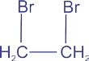viii)

vii) CBr4

|  |  |
| --- | --- |
| ix) CH2Cl2 | x) **(**CH3)3C CH2 CH2 CH2  Br |

xi) 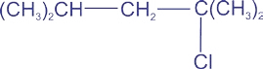 xii) 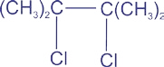

xiii) **(**CH3CH2)3CBr

23

**Q.7.** Draw all the possible structures that have the molecular formula C6H13CI. Classify each as primary, secondary or tertiary chloride. Give their names according to IUPAC system.

**Q.8.** Using ethyl bromide as a starting material how would you prepare the following

compounds. Give also the inorganic reagents and conditions necessary to carry out these reactions:

(a) n-Butane (b) Ethyl alcohol

(c) Ethyl cyanide (d) Ethane

(e) Ethene (f) Propanoic acid (g) Propane

**Q.9.** Write a detailed note on the mechanism of nucleophilic substitution reactions.

**Q.10.** What do you understand by the term b-elimination reaction. Explain briefly the two possible mechanisms of 3-elimination reactions.

**Q.11.** What products are formed when the following compounds are treated with ethyl magnesium bromide, followed by hydrolysis in the presence of an acid,

i) HCHO ii) CH3CHO iii) CO2  iv) (CH3)2CO v) CH3— CH2— CHO vi) CICN

**Q. 12.** How will you carry out the following conversions.

i) CH4 CH3CH2COOH ii) CH3— CH3 (CH3— CH2)4N+ Br iii) CH2 = CH2 CH3— CH2— CH2— CH2 — OH iv) CH3CH2CH2CI CH3— CH = CH2

24

v) CH3COOH CH3CH2COOH